Database Design :Authentication & Authorization

Sai Phapale , Swaraj Bhagat ,Varad Karve

System Users-
  - Principal,
  - Vice Principal
  - HOD
  - Faculty (Class & Subject Teachers)
  - Students
  - Accountant
  - Exam Controller
  - Training & Placement Cell
  - Physical Director
  - Admin
  - IT Admin
  - Visitors

1)Functional Requirements of Database
- Register users
- Store encrypted passwords
- Authenticate users (username + password)
- Assign roles to users
- Assign permissions to roles
- Restrict module access based on role
- Maintain login history

2)Non-Functional Requirements of Database
- High security(Achieved by RBAC, login_log)
- Password hashing(Achieved by using hashing algorithms like bcrypt)
- Scalable user handling(Separate tables for users, roles, and permissions)
- Data integrity(Achieved by PK,FK,NOT NULL,UNIQUE CONSTRAINTS)

Core Entities of Database

1. users
Stores all registered system users with login credentials and account status.
Acts as the main authentication entity.
Field Name | Data Type | Constraints
user_id | INT | PRIMARY KEY, AUTO_INCREMENT
username | VARCHAR(50) | NOT NULL, UNIQUE
email | VARCHAR(100) | NOT NULL, UNIQUE
password_hash | VARCHAR(255) | NOT NULL
status | BOOLEAN | NOT NULL, DEFAULT TRUE
created_at | TIMESTAMP | NOT NULL, DEFAULT CURRENT_TIMESTAMP
updated_at | TIMESTAMP | NOT NULL, DEFAULT CURRENT_TIMESTAMP ON UPDATE CURRENT_TIMESTAMP

Example-
user_id | username | email | password_hash | status | created_at | updated_at
1 | principal01 | principal@school.com | hashed123 | TRUE | 2026-02-01 09:00 | 2026-02-01 09:00
2 | teacher01 | teacher@school.com | hashed456 | TRUE | 2026-02-02 10:00 | 2026-02-02 10:00
3 | student01 | student@school.com | hashed789 | TRUE | 2026-02-03 11:00 | 2026-02-03 11:00

2. roles

Stores predefined system roles (Principal, Faculty, Student, Admin, etc.).
Field Name | Data Type | Constraints
role_id | INT | PRIMARY KEY, AUTO_INCREMENT
role_name | VARCHAR(50) | NOT NULL, UNIQUE
description | TEXT | Optional (can be NULL)
created_at | TIMESTAMP | NOT NULL, DEFAULT CURRENT_TIMESTAMP
updated_at | TIMESTAMP | NOT NULL, DEFAULT CURRENT_TIMESTAMP ON UPDATE CURRENT_TIMESTAMP

Example-
role_id | role_name | description | created_at | updated_at
1 | Principal | Head of school | 2026-02-01 08:00 | 2026-02-01 08:00
2 | Faculty | Teaching staff | 2026-02-01 08:05 | 2026-02-01 08:05
3 | Student | School student | 2026-02-01 08:10 | 2026-02-01 08:10
4 | Admin | System administrator | 2026-02-01 08:15 | 2026-02-01 08:15

3. user_roles
links users and roles.Allows one user to have multiple roles.
Field Name | Data Type | Constraints
user_role_id | INT | PRIMARY KEY, AUTO_INCREMENT
user_id | INT | NOT NULL, FOREIGN KEY → users(user_id)
role_id | INT | NOT NULL, FOREIGN KEY → roles(role_id)
created_at | TIMESTAMP | NOT NULL, DEFAULT CURRENT_TIMESTAMP
updated_at | TIMESTAMP | NOT NULL, DEFAULT CURRENT_TIMESTAMP ON UPDATE CURRENT_TIMESTAMP

Example-
user_role_id | user_id | role_id | created_at | updated_at
1 | 1 | 1 | 2026-02-01 09:05 | 2026-02-01 09:05
2 | 1 | 4 | 2026-02-01 09:06 | 2026-02-01 09:06
3 | 2 | 2 | 2026-02-02 10:05 | 2026-02-02 10:05
4 | 3 | 3 | 2026-02-03 11:05 | 2026-02-03 11:05

4. permissions

Stores individual actions that can be performed (create, update, view, delete).
Field Name | Data Type | Constraints
permission_id | INT | PRIMARY KEY, AUTO_INCREMENT
permission_name | VARCHAR(100) | NOT NULL
action | VARCHAR(50) | NOT NULL
module_id | INT | NOT NULL, FOREIGN KEY → modules(module_id)
created_at | TIMESTAMP | NOT NULL, DEFAULT CURRENT_TIMESTAMP
updated_at | TIMESTAMP | NOT NULL, DEFAULT CURRENT_TIMESTAMP ON UPDATE CURRENT_TIMESTAMP

Example-
permission_id | permission_name | action | module_id | created_at | updated_at
1 | View Dashboard | view | 1 | 2026-02-01 07:30 | 2026-02-01 07:30
2 | Mark Attendance | create | 2 | 2026-02-01 07:35 | 2026-02-01 07:35
3 | Edit Attendance | update | 2 | 2026-02-01 07:40 | 2026-02-01 07:40
4 | View Reports | view | 3 | 2026-02-01 07:45 | 2026-02-01 07:45

5. role_permissions

Junction table that assigns permissions to roles.Defines what each role is allowed to do.
Field Name | Data Type | Constraints
role_permission_id | INT | PRIMARY KEY, AUTO_INCREMENT
role_id | INT | NOT NULL, FOREIGN KEY → roles(role_id)
permission_id | INT | NOT NULL, FOREIGN KEY → permissions(permission_id)
created_at | TIMESTAMP | NOT NULL, DEFAULT CURRENT_TIMESTAMP
updated_at | TIMESTAMP | NOT NULL, DEFAULT CURRENT_TIMESTAMP ON UPDATE CURRENT_TIMESTAMP

Example-
role_permission_id | role_id | permission_id | created_at | updated_at
1 | 1 | 1 | 2026-02-01 09:10 | 2026-02-01 09:10
2 | 1 | 4 | 2026-02-01 09:11 | 2026-02-01 09:11
3 | 2 | 2 | 2026-02-02 10:10 | 2026-02-02 10:10
4 | 2 | 3 | 2026-02-02 10:11 | 2026-02-02 10:11
5 | 3 | 1 | 2026-02-03 11:10 | 2026-02-03 11:10

6. modules

Stores different system modules (Dashboard, etc.).
Permissions are grouped under modules.
Field Name | Data Type | Constraints
module_id | INT | PRIMARY KEY, AUTO_INCREMENT
module_name | VARCHAR(100) | NOT NULL, UNIQUE
description | VARCHAR(255) | Optional (can be NULL)
created_at | TIMESTAMP | NOT NULL, DEFAULT CURRENT_TIMESTAMP
updated_at | TIMESTAMP | NOT NULL, DEFAULT CURRENT_TIMESTAMP ON UPDATE CURRENT_TIMESTAMP

Example-
module_id | module_name | description | created_at | updated_at
1 | Dashboard | Main system page | 2026-02-01 07:00 | 2026-02-01 07:00
2 | Attendance | Manage attendance | 2026-02-01 07:10 | 2026-02-01 07:10
3 | Reports | View system reports | 2026-02-01 07:20 | 2026-02-01 07:20

7.refresh_tokens
Field Name | Data Type | Constraints
refresh_token_id | INT | PRIMARY KEY, AUTO_INCREMENT
user_id | INT | NOT NULL, FOREIGN KEY → users(user_id)
token | VARCHAR(255) | NOT NULL, UNIQUE
expiry_date | TIMESTAMP | NOT NULL
created_at | TIMESTAMP | NOT NULL, DEFAULT CURRENT_TIMESTAMP
updated_at | TIMESTAMP | NOT NULL, DEFAULT CURRENT_TIMESTAMP ON UPDATE CURRENT_TIMESTAMP

Example-
refresh_token_id | user_id | token | expiry_date | created_at | updated_at
1 | 1 | tokenABC | 2026-03-01 00:00 | 2026-02-10 09:00 | 2026-02-10 09:00
2 | 1 | tokenXYZ | 2026-03-01 00:00 | 2026-02-10 09:05 | 2026-02-10 09:05
3 | 2 | tokenLMN | 2026-03-01 00:00 | 2026-02-11 10:00 | 2026-02-11 10:00

8.login_log

Tracks user login activity including login time, IP address, and device information.
Used for auditing and security monitoring.
Field Name | Data Type | Constraints
login_log_id | INT | PRIMARY KEY, AUTO_INCREMENT
user_id | INT | NOT NULL, FOREIGN KEY → users(user_id)
ip_address | VARCHAR(45) | NOT NULL
device_info | VARCHAR(255) | Optional (can be NULL)
status | VARCHAR(50) | NOT NULL
login_time | TIMESTAMP | NOT NULL, DEFAULT CURRENT_TIMESTAMP
created_at | TIMESTAMP | NOT NULL, DEFAULT CURRENT_TIMESTAMP
updated_at | TIMESTAMP | NOT NULL, DEFAULT CURRENT_TIMESTAMP ON UPDATE CURRENT_TIMESTAMP

Example-
login_log_id | user_id | ip_address | device_info | status | login_time | created_at | updated_at
1 | 1 | 192.168.1.10 | Chrome PC | Success | 2026-02-10 09:00 | 2026-02-10 09:00 | 2026-02-10 09:00
2 | 2 | 192.168.1.15 | Android | Success | 2026-02-11 10:00 | 2026-02-11 10:00 | 2026-02-11 10:00
3 | 3 | 192.168.1.20 | Chrome PC | Failed | 2026-02-12 11:00 | 2026-02-12 11:00 | 2026-02-12 11:00

Relationships

1)Users → User_Roles (1:M)
One user can have multiple roles in the system.

2)Roles → User_Roles (1:M)
One role can be assigned to many users.
This creates a many-to-many relationship between users and roles.

3)Roles → Role_Permissions (1:M)
One role can have multiple permissions.
Each record defines what actions that role is allowed to perform.

4️)Permissions → Role_Permissions (1:M)
One permission can be given to many roles.
This creates a many-to-many relationship between roles and permissions.

5)Modules → Permissions (1:M)
One module contains multiple permissions (like create, edit, delete).
Each permission belongs to only one module.

6️)Users → Refresh_Tokens (1:M)
One user can have multiple refresh tokens (for multiple devices).
Each token belongs to only one user.

7️)Users → Login_Log (1:M)
One user can have many login records.
Each login log entry belongs to one user.

Entity Relationship Diagram (ERD)

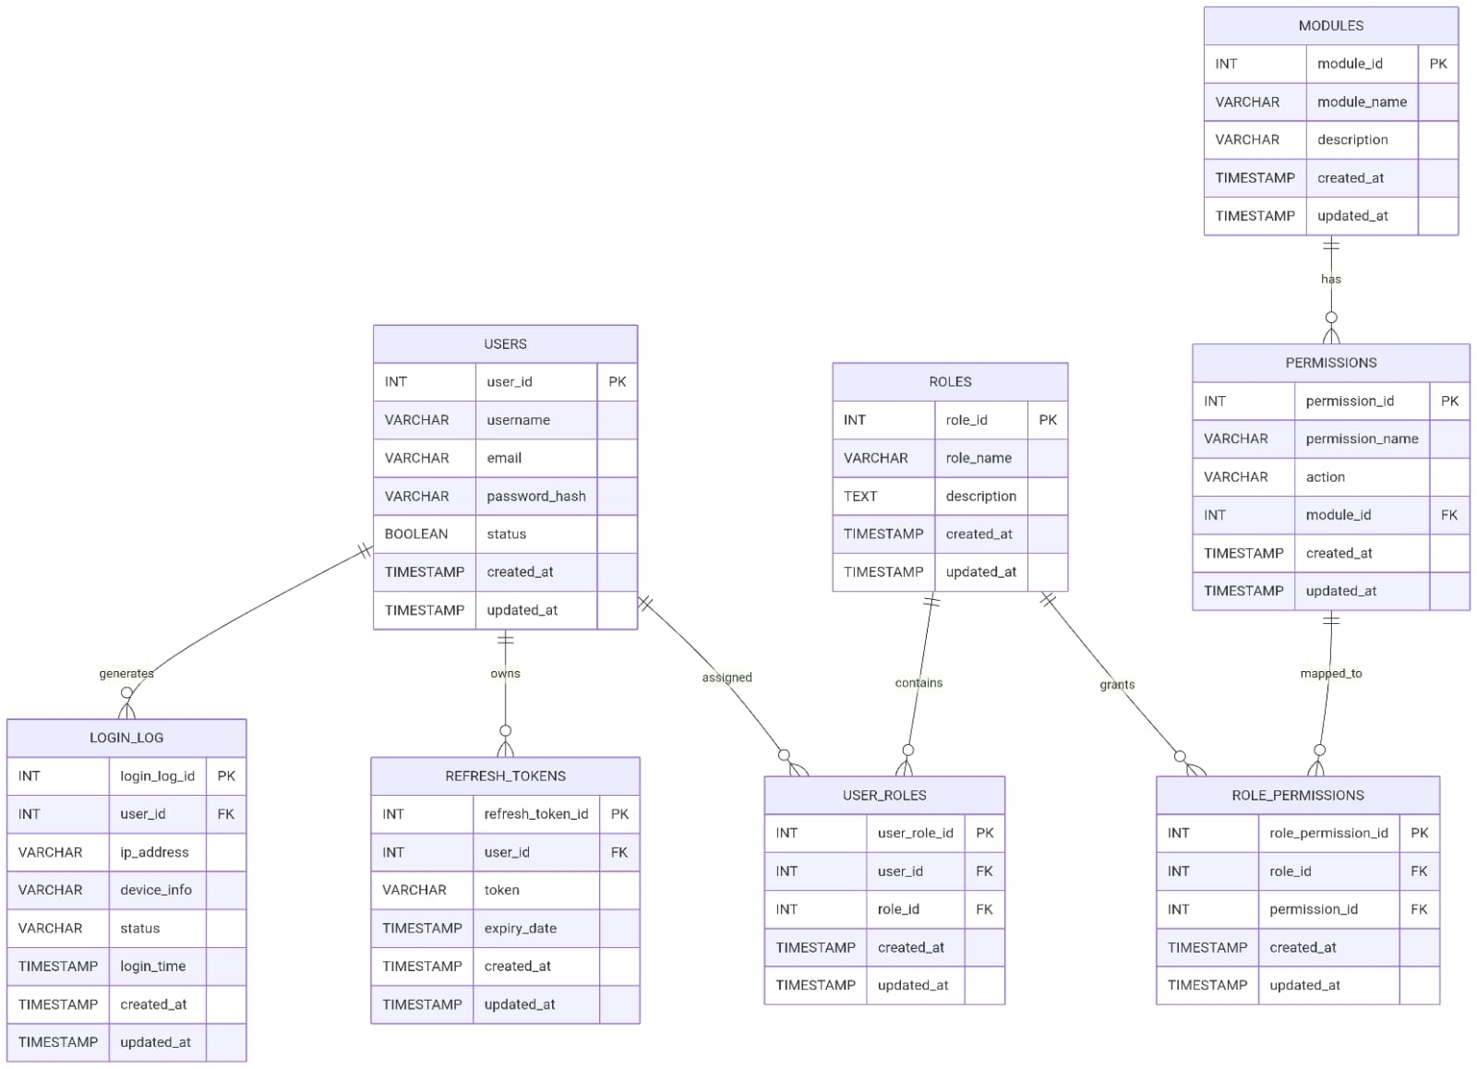

Login Flow
